4CS017/UM1: Internet Software Architecture and Databases – Prototype 03 – reflective report
Link to my weather app :- https://mi-linux.wlv.ac.uk/~2441880/prototype3.html
Link to Bootstrap weather app:- https://mi-linux.wlv.ac.uk/~2441880/bootstrap.html

Strengths
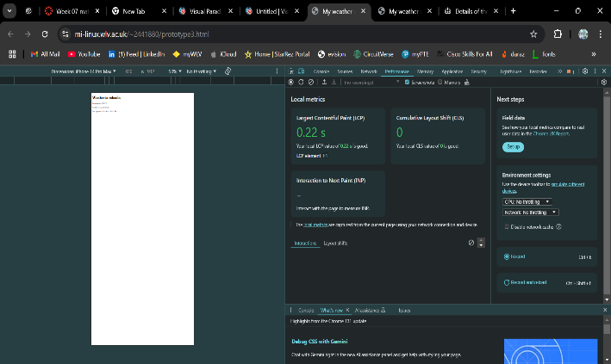
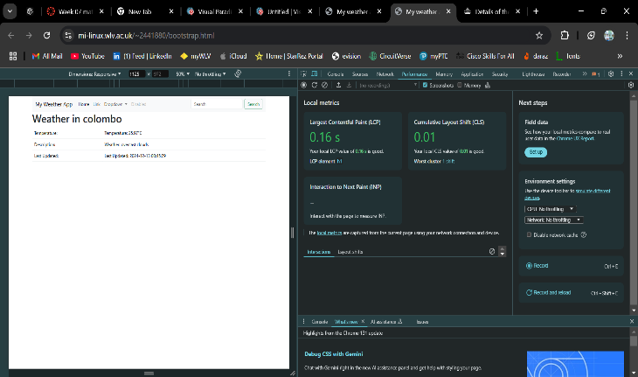
- There is an improvement in the performance in the API such as it goes from 20 to 5 to fetch the data. After 10 seconds of refreshing the page the data from the be browser in the device will get updated. In prototype 1 the developer moved the date which was fetched from the Germany every single time whereas the prototype 2 the data fetched from the Linux until it expired the session. And also can read the data even when the device is offline in the Prototype 3. This is a major strength in this prototype. The users can access the application and netwok to find out what the session appearing after they refresh the page after every 10 seconds. The updated data will appear in the web application.

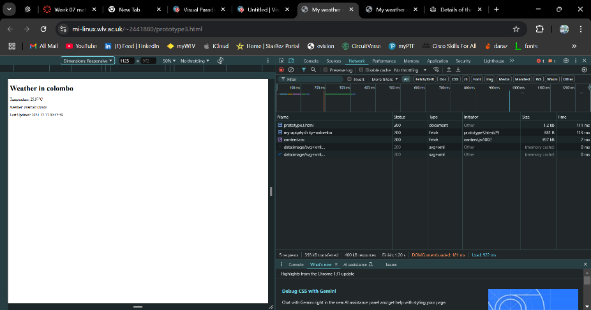

Weaknesses
- This prototype takes lots of storage to store the data that client requests every 10seconds. Sometimes if the cached data it saves in the browser isn’t encrypted, so it’s not very secure to store data. The app depends on a single Linux server for both PHP processing and database operations, which makes it vulnerable to server outages since there is no backup or failover system. Security is another issue, as the app does not use HTTPS for secure communication or encrypt sensitive data like API key additionally, the 10-second cache duration does not effectively reduce API calls, leading to frequent requests.

